## Abstract:

## Virtual reality, robotics, and Augmented reality can team up to develop innovative applications for various organizations. In this project a robot with a camera is placed in a remote location to capture the environment in visual form using Raspberry Pi (RPi). The captured visuals are displayed on the user’s virtual reality (VR) headset. An added feature allows the camera to move in the direction of the user’s head movements. This gives the user a real time experience a if he is present where the virtual tele-presence robot is located. The virtual telepresence robot can also be moved in any direction through an app installed in the users smartphone.

## Introduction:

**Virtual Reality(VR):**

## Virtual reality (VR) is a [simulated](https://en.wikipedia.org/wiki/Simulation) experience that employs [pose tracking](https://en.wikipedia.org/wiki/Pose_tracking) and [3D near-eye displays](https://en.wikipedia.org/wiki/3D_near-eye_display) to give the user an immersive feel of a virtual world. [Applications of virtual reality](https://en.wikipedia.org/wiki/Applications_of_virtual_reality) include entertainment (particularly [video games](https://en.wikipedia.org/wiki/Video_game)), education (such as medical or military training) and business (such as virtual meetings). Other distinct types of VR-style technology include [augmented reality](https://en.wikipedia.org/wiki/Augmented_reality) and [mixed reality](https://en.wikipedia.org/wiki/Mixed_reality), sometimes referred to as [extended reality](https://en.wikipedia.org/wiki/Extended_reality) or XR, although definitions are currently changing due to the nascence of the industry.

## The video captured by Rpi camera can be viewed on a smartphone placed in the virtual reality

## (VR) headset. The project lets the user experience virtual reality through VR headset. Dual-

## screen mode is enabled in the smartphone for this purpose. The smartphone reads the accelerometer and magnetometer data of the direction in which the user turns his head, say, right or left. This data is sent to the modem over wi-fi and to the Rpi board, which, in turn provides these values as inputs to the servo motors. Two servo motors are used to move the camera one for the vertical movement and the other for the horizontal movement. So when you turn your head along with VR headset to the right side , the RPi camera will also turn to the right direction.

## Augmented reality (AR):

## Augmented reality is an interactive experience that combines the real world and computer-generated content. The content can span multiple sensory [modalities](https://en.wikipedia.org/wiki/Modality_(human%E2%80%93computer_interaction)), including [visual](https://en.wikipedia.org/wiki/Visual), [auditory](https://en.wikipedia.org/wiki/Hearing), [haptic](https://en.wikipedia.org/wiki/Haptic_perception), [somatosensory](https://en.wikipedia.org/wiki/Somatosensory_system) and [olfactory](https://en.wikipedia.org/wiki/Olfactory). AR can be defined as a system that incorporates three basic features: a combination of real and virtual worlds, real-time interaction, and accurate 3D registration of virtual and real objects. The overlaid sensory information can be constructive (i.e. additive to the natural environment), or destructive (i.e. masking of the natural environment). This experience is seamlessly interwoven with the physical world such that it is perceived as an [immersive](https://en.wikipedia.org/wiki/Immersion_(virtual_reality)) aspect of the real environment. In this way, augmented reality alters one's ongoing perception of a real-world environment, whereas [virtual reality](https://en.wikipedia.org/wiki/Virtual_reality) completely replaces the user's real-world environment with a simulated one.

**LITERATURE SURVEY**

## Paper 1 - Jingxin Zhang Department of Informatics, University of Hamburg, Germany

## Methods:

## Telepresence systems nowadays are becoming increasingly common in our daily lives and has enormous potential for different application domains ranging from business, tourism, meetings, entertainment to academic conferences, education, and remote health care. Telepresence refers to a set of technologies, which aim to convey the feeling of being in a different place than the space where a person is physically located. Therefore, telepresence systems should allow humans to move through the remote environment, interact with remote artifacts or communicate with the remote people. However, current telepresence systems usually lack natural ways of supporting interaction and exploration of remote environments (REs). In particular, most current telepresence platforms consist of mobile webcams with speakers and microphones. As a result, the usage of single webcams for capturing the RE provides the users with a very narrow field of view and a limited illusion of spatial presence. Both issues limit the sense of presence of teleoperators. In addition, the deficiency of visual information about the RE can lead to a high error-rate for teleoperation tasks and remote interactions. Furthermore, typical movement controls of mobile platforms in today’s telepresence systems are often `restricted to simple interaction devices, such as joysticks, touchpads, mice or keyboards. As such operators have to use their hands in order to control the mobile platform and, therefore, the hands are not free to perform other tasks simultaneously. This may decrease the naturalness, task performance and overall user experience

## Limitations –

## • analysis the limitations and challenges of telepresence systems nowadays, propose a concept of novel telepresence system. According to this concept, design and develop a prototype of novel telepresence system.

## • establish effective interaction between novel telepresence system and user, such that the user can explore a remote environment using this setup in a natural way.

## • verify former study results of RDW and transfer the RDW technology from virtual environment into 360◦ video-based telepresence system.

## • give available interactive strategies on the problems in the process of human-robot interaction, such as the latency of remote image update.

## • learn what kind of interactive mode users perceive as the most natural one by evaluating the results of human-robot interaction in different cases using this setup.

## Paper 2 - Nandagopal Harikrishnan Dept. of ECE Mar Baselios College of Engineering and Technology Thiruvananthapuram, India

## Methods

## The first stage of the work focuses on the Arduino based four wheeled robots. The board that will be used is an Arduino coupled to 4 geared motors which power the wheels. The Bluetooth module will also be connected to the Arduino board. First stage of testing would involve controlling the robot using a basic Bluetooth enabled controller. Building the pedometer comes in the second stage. The values obtained from the accelerometer contain unwanted noise signals. It may badly affect the step counting. The noise signal must be properly filtered using appropriate filters to initiate step counting. For this purpose, we are using Kalman filters. It is an optimal estimator which creates an estimate of the unknown value using the previous state estimate and the current input data. This algorithm is based on minimizing the mean square deviation. The Kalman filter process is as follows: Predict the next covariance as: Pc=P + varProcess. where Pc-predicted covariance, p-covariance of the sensor data and varProcess-process covariance. Compute the Kalman gain: G=P/ (Pc + varVolt) where G-Kalman gain and varVolt-variance determined using excel and reading samples of raw sensor data. Update the covariance of the sensor output: P=(1-G) *Pc Compute the Kalman estimate of the sensor voltage: Xe=G*(netmag-Xp) + Xp where Xe-Kalman estimate of the sensor voltage, Xpprevious Kalman estimate and netmag is the net magnitude of the sensor output along the x,y and z axes. The net magnitude is computed as: netmag x2 + y2 + z2 Once we have the filtered output, we need to determine a threshold value to be set to initiate step counting. For that purpose, different users were allowed to wear the smartphone in the band and made to walk in different ways. The accelerometer values are continuously monitored for each user and finally a threshold value is determined and was set in the program code. If a user takes a step and if the filtered accelerometer values crosses the threshold, then it is counted as a step and the robot moves accordingly. Since the determination of threshold experiment is conducted in many peoples, the advantage is that even the minor movements in the legs or hands will not result in step counting. The rotation of the robot according to the user's motion is controlled using the magnetometer values from the smartphone worn by the user. All the computations are performed with respect to the Earth’s magnetic field. The robot is coded in such a way that when it is powered on, it initially checks the user direction and changes its direction accordingly. For example, when the robot is powered on, assume the user is standing in the north-east direction while the robot is facing the north direction. The robot detects a mismatch in direction and in order to correct it turns to the right by 45 degrees. After matching the directions, it will continue to move like the user. After every movement the robot direction is compared with the user direction to check whether the user has turned right or left and if any mismatch is found the robot corrects it’s direction accordingly. Once the pedometer is tested for accurate step counting, it is then connected to the robot via Bluetooth and the code is modified to act as the controller. Third stage involves integrating Virtual Reality using a Raspberry Pi board to which the camera module is connected. The camera module is rotated by a servo motor arrangement. A camera mount with two servo motors to enable both pan and tilt movement is attached at the top of the robot that resembles the user's head. After setting the initial data, when the user moves his/her head, the gyroscope values will also change and these values are used for computing how much the camera mount to be moved. In the final stage a dual screen app is used to split the screen that allows the users to open two applications at once on the smartphone that acts as the display for the VR headset. This stage also involves connecting the smartphone to the Raspberry Pi and making the VR headset the directional controller for the camera.

# Paper3 **-** Application of redirected walking in room-scale VR

## [Eike Langbehn](https://ieeexplore.ieee.org/author/37085793774), [Paul Lubos](https://ieeexplore.ieee.org/author/37085995102), [Gerd Bruder](https://ieeexplore.ieee.org/author/37304364100), [Frank Steinicke](https://ieeexplore.ieee.org/author/37304363900)

## Redirected walking (RDW) promises to allow near-natural walking in an infinitely large virtual environment (VE) by subtle manipulations of the virtual camera. Previous experiments showed that a physical radius of at least 22 meters is required for undetectable RDW. However, we found that it is possible to decrease this radius and to apply RDW to room-scale VR, i. e., up to approximately 5m × 5m. This is done by using curved paths in the Ve instead of straight paths, and by coupling them together in a way that enables continuous walking. Furthermore, the corresponding paths in the real world are laid out in a way that fits perfectly into room-scale VR. In this research demo, users can experience RDW in a room-scale head-mounted display VR setup and explore a VE of approximately 25m × 25m.

## METHODOLOGY -

Directional data or command from the smartphone is sent to the navigation circuit through HC-05 Bluetooth module. It is processed by the Arduino and then fed to the motor driver IC, which drives the geared motor in the required direction. Commands are given to the Bluetooth Electronics app installed in the smartphone. First, you need to open the Bluetooth Electronics app and pair with the HC-05 module as shown in Fig. 3. Once the two devices are paired, the buttons are edited in the app and configured with English alphabet characters. Each direction (forward, backward, right and left) is assigned a character. Four buttons are used as shown in Fig. 4. When these buttons are pressed, the corresponding characters get transmitted.

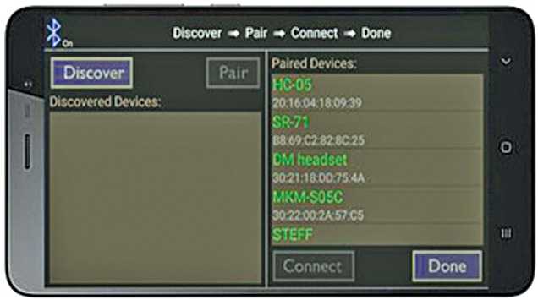

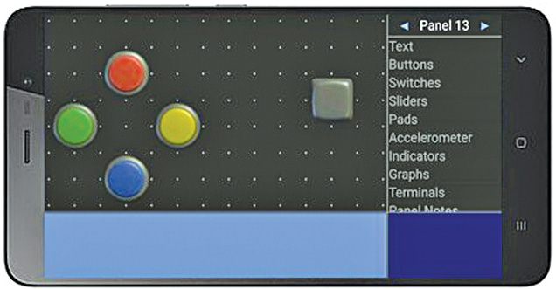

## Depending on the data received from the Bluetooth module, the motor moves in forward or backward direction.

## There are four wires connected to the geared motors from Board2 having ATmega2560 microcontroller (MCU). Arduino Mega is used because it has 16 analogue channels and can be used to connect different sensors. The flow-chart (Fig. 6) depicts the algorithm used in the navigation program (Arduino bluetooth.ino) burnt into the MCU of Arduino.

## 

Capturing live video - Servo motors are connected to GPIO pins of RPi. In order to control the position of the camera, two servo motors (M1 and M2) are used to move the camera in X and Y directions.

Download the Wireless IMU app from Play Store and install in your smartphone. The app supports accelerometer, gyroscope and magnetometer, and can be made to run in the background. The values from this app are sent to the RPi through UDP protocol. The magnetometer values make the servos move in either right or left direction. The accelerometer values make the servos move up and down. Only Z direction is used in the project. The algorithm for servo control is shown in Fig. 7. Thus, the camera can capture live video at different angles.

## 

## Arduino Mega 2560

### Arduino Mega 2560 is a microcontroller board based on the ATmega2560. It has 54 digital input/output pins (of which 15 can be used as PWM outputs), 16 analogue inputs, four UARTs (hardware serial ports), a 16MHz crystal oscillator, a USB connection, a power jack, an ICSP header and a reset button. It contains everything needed to support the microcontroller; simply connect it to a computer with a USB cable or power it with an AC-to-DC adaptor or battery to get started. The Mega 2560 board is compatible with most shields designed for the Uno. It is an update to the Arduino Mega.

The Arduino board acts as the directional processor of the virtual telepresence robot. Commands to drive the virtual telepresence robot in the specified direction are processed and given by the Arduino to a driver IC, which, in turn,causes the motors to run. The Mega 2560 board can be programmed with the Arduino software (IDE). ATmega2560 on the board comes pre programmed with a bootloader that allows you to upload new code to it without using an external hardware programmer. The Mega 2560 board can be powered via USB connection or with an external power supply. The power source is selected automatically. External (non-USB) power can come either from an AC-to-DC adaptor (wall-wart) or battery. The board can operate on an external supply of 6-20 volts. The recommended power supply range is 7-12 volts. At mega2560 has 256kB of flash memory for storing code (of which 8kB is used for the bootloader), 8kB SRAM and 4kB EEPROM. The Mega 2560 board has a number of facilities to communicate with a computer, another board or other microcontrollers. An ATmega16U2 on the board channels one of these over USB and provides a virtual COM port to software on the computer.

### **Geared motor**

Geared motors are a specific type of electrical motors that produce a high torque while maintaining a low-horsepower or low-speed motor output. These can be either AC (alternating current) or DC (direct current). They also have two different speed specifications—normal speed and stall-speed torque.

DC geared motors are primarily used to reduce speed in a series of gears, which, in turn, creates more torque. This is accomplished by an integrated series of gears or a gear box attached to the main motor rotor and shaft via a second reduction shaft. The second shaft is then connected to the series of gears or gearbox to create what is known as a series of reduction gears.

### **Servo motor**

Servo motor is a rotatory actuator or linear actuator that allows for precise control of angular or linear position, velocity and acceleration. It consists of a suitable motor coupled to a sensor for position feedback. It also requires a relatively sophisticated controller, often a dedicated module designed specifically for use with the servo motors. It is not a specific class of motor, although the term servomotor is often used to refer to a motor suitable for use in a closed loop control system. Two servo motors are used in this project.

### **Bluetooth module**

HC-05 module is an easy-to-use Bluetooth SPP (serial port protocol) module designed for transparent wireless serial connection setup. Serial port Bluetooth module is a fully qualified Bluetooth V2.0+EDR (Enhanced Data Rate) 3Mbps modulator with complete 2.4GHz radio transceiver and baseband. It uses CSR Bluecore 04-External single-chip Bluetooth system with CMOS technology and AFH (adaptive frequency hopping) feature. Its default baud rate is 38400, has eight data bits, one stop bit and no parity. It supports following baud rates: 9600, 19200, 38400, 57600, 115200, 230400 and 460800.

### **Camera module**

A camera module is an image sensor integrated with a lens, control electronics and an interface like CSI, Ethernet or plain raw low-voltage differential signaling. The Raspberry Pi camera module can be used to take high-definition videos as well as still photographs. The module has a five megapixel fixed-focus camera that supports 1080p30, 720p60 and VGA90 video modes as well as stills capture. It attaches via a 15cm ribbon cable to the CSI port on the Raspberry Pi. It can be accessed through the MMAL and V4L APIs, and there are numerous third-party libraries built for it, including the Picamera Python library.

### **Raspberry Pi and video configurations**

RPi is used in this project because it allows easy video transmission over Wi-Fi. The RPi is considered as the CPU of the virtual telepresence robot. The Raspberry Pi 3 (RPi 3) Model B used here is the third-generation RPi. This powerful credit-card sized single-board computer can be used for many applications. RPi 3 Model B released in February 2016 is bundled with on-board Wi-Fi, Bluetooth and USB boot capabilities. The RPi 3 uses a Broadcom BCM2837 SoC with a 1.2GHz 64-bit quad-core ARM Cortex-A53 processor, with 512kB shared L2 cache.

### **The next main step is the setting up of the RPi**

After initial configuration of RPi is done, the RPi board is connected to Wi-Fi. An IP address is programmed and setup is linked to the RPi. The video captured by the RPi camera is sent over the Wi-Fi modem. This video can be viewed in your smartphone by connecting to the same Wi-Fi connection and IP address of the RPi.

The RPi is powered up using a 5V, 10000mAh power bank (Xiaomi). Then an SD card with the Raspbian software is inserted into the slot provided in the RPi board. The board is connected to a monitor for further configuration. The RPi configuration tool in Raspbian allows you to easily enable features and change your specific settings like keyboard layout. The procedure for the initial setting up is as follows:

1.Acces the terminal window on mac or windows.

2. Run wirelessly with a static IP for each SD card.

3. Automatically startup.

4. Set the time zone

5. Skip the GUI

Once the above setup is complete, we can see the desktop screen on RPi monitor. In order to view the desktop again we need to access via the remote desktop.

To get the remote desktop in some laptops it is mandatory to install the XRDP software, as shown in Fig. 8. The user name and password are entered in the screen. Then IP address of the computer is entered as shown in Fig. 9. The RPi is accessed by entering the username and password as shown in Fig. 10. The desktop of the RPi opens up as shown

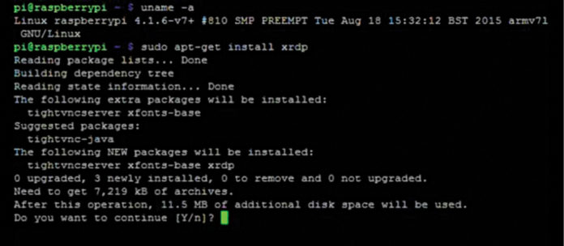

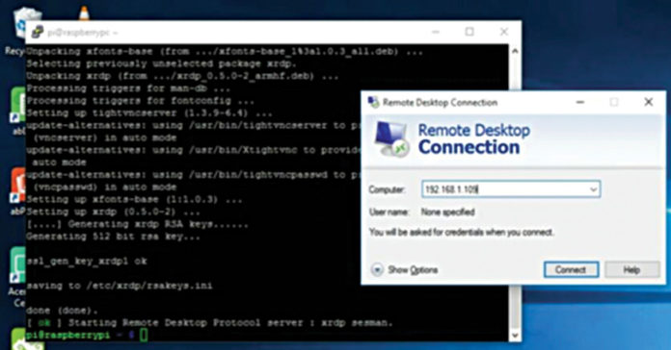

## Software

## Apache web server

Apache is used in this project to configure RPi as server. Apache is a popular web server application that you can install on the RPi to allow it to serve web pages. Apache can serve HTML files over HTTP, and with additional modules it can serve dynamic web pages using scripting languages such as PHP. First install the Apache package by typing the following command in the Terminal:

**Sudo apt-get install appache2 -** By default, Apache puts a test HTML file in the web folder. This default web page is served when you browse http://192.168.1.98 from another computer on the network. Browse the default web page either on the RPi or from another computer on the network; you would see the default page. Next, install PHP5 by giving the following command in the Terminal

**Sudo apt-get install php5 -** RPi cam web interface. The RPi is connected to the Ethernet and configured to access the Internet. It is then made to connect to the LAN via Wi-Fi. Then an RPi camera module is connected to Board1. Still images are captured and the result is checked in the RPi cam web interface page of the Raspberry Pi. The same configurations are done to get video transmission. Installation of RPi Cam Web Interface is shown in Fig. 12, final web page in Fig. 13 and camera setting in Fig. 14.

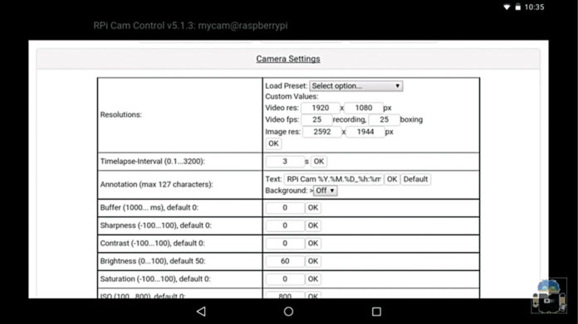

### **Python**

Python is a widely used high-level programming language for general-purpose programming. Python programs don’t need to be compiled before running them. However, the Python interpreter must be installed on the computer to run them. The Python interpreter is a program that reads Python files and executes the code. The python_camera.py code is used in the RPi board to control the servo motors.

### **Arduino IDE**

The open source Arduino software (IDE) makes it easy to write code and upload it to the board. It runs on Windows, Mac OS X and Linux. The environment is written in Java and based on Processing and other open-source software.

### **PHP**

PHP (recursive acronym for PHP: Hypertext Preprocessor) is a widely-used open source general-purpose scripting language that is especially suited for web development and can be embedded into HTML. It is especially suited to server-side web development, in which case PHP generally runs on a web server. Any PHP code in a requested file is executed by the PHP runtime, usually to create dynamic web page content or dynamic images used on websites or elsewhere. PHP5 is used in this project to run and edit default webpage.

### **Wireless IMU app**

This app (Fig. 16) measures and reports a body’s specific force, angular rate and sometimes the magnetic field surrounding the body, using a combination of accelerometers and gyroscopes, and sometimes magnetometers. An inertial measurement unit (IMU) works by detecting the current rate of acceleration using one or more accelerometers, and detects changes in rotational attributes like pitch, roll and yaw using one or more gyroscopes. And some also include a magnetometer, mostly to assist calibration against orientation drift. The accelerometers are placed such that their measuring axes are orthogonal to each other. Three gyroscopes are placed in a similar orthogonal pattern, measuring rotational position in reference to an arbitrarily chosen coordinate system. Magnetometers allow better performance for dynamic orientation calculation in attitude and heading reference systems.

### **Dual screen**

The DualScreen app by Goestoweb allows the screen of the smartphone to be shown in two different parts. This is done to get accurate visuals through the VR lens. There are two eyepieces in VR headset, hence dual-screen mode is used.

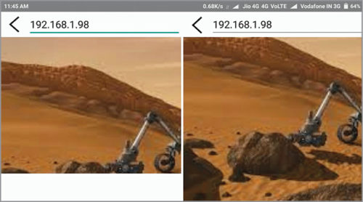

### **Bluetooth Electronics**

This application by Keuwlsoft has to be installed in the smartphone. It allows the user to drive the motor from the smartphone. The directions of the virtual telepresence robot are sent via Bluetooth.

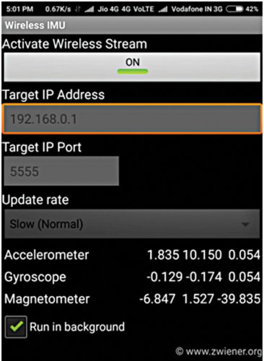

## Project Pipeline:

## 1.Phase1:

## Achieve live streaming of live video from Rpi camera (Raspberry Pi) on to phone display.

## 2.Phase2:

## Achieve remote control head movement of sensor controlling servo motors

## 3.Phase3:

## Integrate with a Remotecontrolled robot.

## FACILITIES REQUIRED FOR PROPOSED WORK

## 1.Hardware Requirements:

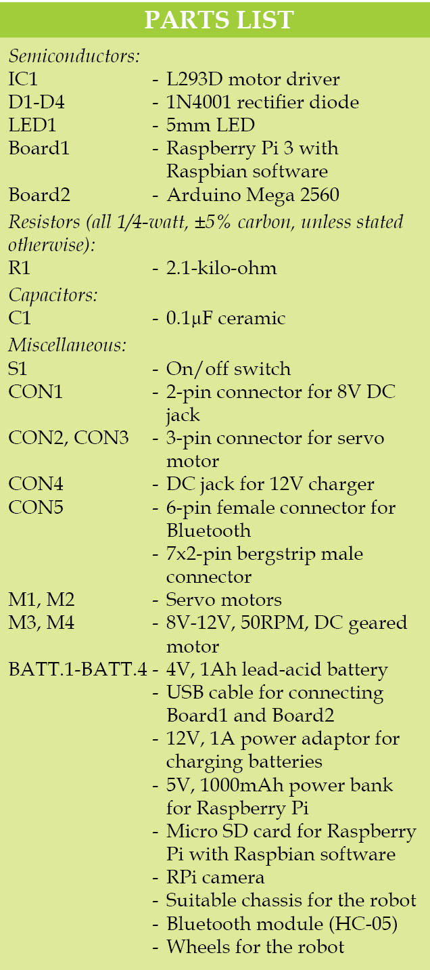

## 2. Software Requirements:

## Python

## Arduino

## Graphics Engine: Unity Engine or Unreal Engine

## VR Headset

## API’s

## VR SDK

## BIBLIOGRAPHY

Dhahran Jadhav, Parth Shah, Henil Shah, “A Study to design VI classrooms using Virtual Reality aided Telepresence”, IEEE 18th International Conference on Advanced Learning Technologies, 2018, pp. 319-321.

Keerthi Premkumar. K Gerard Joe Mr, Nigel, Wi-Fi Android Smart Phone Based Robotic Arm Control Using Raspberry Pi IEEE Sponsored 2nd International Conference on Innovations in Information Embedded and Communication Systems